Python Based Battery Control System for Smart Energy Grid Integration

ENGN4200 Individual Project Thesis

Patrick Wilton | 2019

A thesis submitted for the degree of Bachelor of Engineering (Honours)

Research School of Electrical, Energy and Materials Engineering

*I declare that this thesis is my own original work except where acknowledgement of another source has been made.*

Patrick Wilton

9th September 2019

# Acknowledgements

I would personally like to thank my supervisor Lachlan Blackhall for providing me with this research opportunity even with my small amount of control systems knowledge going into this project. Although he was often busy throughout my time completing my honours, his words of encouragement and support kept me from becoming overwhelmed with the tasks ahead, especially in the early days.

I have greatly appreciated the advice of BSGIP team member Benjamin Weise. His words of wisdom helped me through many technical software issues even if I was often able to answer my own questions by simply explaining them to him.

I would also like to thank Bjorn Sturmberg for committing the time to be my secondary supervisor where needed and the entire BSGIP team for their welcoming attitude, especially Deborah Taylor for being so patient with my late email replies.

# Abstract

Written after Results

Table of Contents

Acknowledgements 3

Abstract 4

List of Figures 6

List of Tables 6

Nomenclature 7

1. Introduction 8

1.1 Thesis Statement 8

1.2 Residential Battery Control System Dynamics 8

1.3 Input Data Systems 13

1.4 Battery Models 16

1.5 Motivations 17

1.6 Thesis Outline 17

2. Background and Related Work 18

2.1 Existing Battery Systems 18

2.2 Current Viability Research 18

2.3 BSGIP’s Work 19

3. A Python Based Battery Control System 20

3.1 Hardware Simulation and Program Abstraction 20

3.2 System Capabilities and Limitations 20

3.3 Testing Methods 20

3.4 Results 20

4. Discussion 21

4.1 Technical Assumptions 21

4.2 Results Implications 21

4.3 Financial Incentives 21

5. Conclusions 22

5.1 Battery Systems’ Current Viability 22

5.2 An Open-Source Solution 22

Bibliography 23

# List of Figures

Figure 1: High-Level Sub-Systems 8

Figure 2: PV Self-Consumption Closed Loop Control System 9

Figure 3: Typical PV-Self Consumption Battery 24 Hour Response 9

Figure 4: Peak Minimisation Closed Loop Control System 10

Figure 5: Typical Peak Minimisation Battery 24 Hour Response 10

Figure 6: Load-Shifting Open-Loop Control System 11

Figure 7: Optimisation Battery Control System 13

Figure 8: Input Data Systems Overview 14

Figure 9: Logical Breakdown of Pub-Sub and Req-Rep Models 15

Figure 10: One-Dimensional Kalman Filter Python Code Example 16

Needs Updating

# List of Tables

Table 1: Generalised Comparison of Typical Battery Control Methods 11

Table 2: Typical Specifications for Popular Energy Storage Solutions 16

Needs Updating

# Nomenclature

BSGIP: Australian National University Battery Storage and Grid Integration Program

SOC: State of Charge

DOD: Depth of Discharge

PV: Photo-Voltaic

ROI: Return on Investment

Needs Updating

# Introduction

## Thesis Statement

Current residential energy storage solutions for solar use fail to be financially viable for a vast majority of their Australian customers, where many of the battery options on offer use only simple control methods focusing on PV self-consumption, load-shifting or small amounts of peak minimisation. A higher level of control involving input predictions and output optimisations will provide significant benefits over these systems in many cases. Specifically, a python-based system which simulates hardware protocols can be used to test these different battery control methodologies, provide a valuable insight for customers, and could help improve these systems in the future when energy storage becomes a much more viable addition to the Australian solar powered home.

## Residential Battery Control System Dynamics

It is useful for the purposes of PV systems to think of energy storage not as its name suggests but as a form of control input. The addition of a battery to a PV system does not mean any additional energy is produced or consumed, but rather energy can now be controlled in a different way. This inherently means that the battery is not an isolated system and relies on at least one input to produce at least one output that will affect the state of the system. This residential PV network can, at its highest level, be represented by four distinct sub-systems:

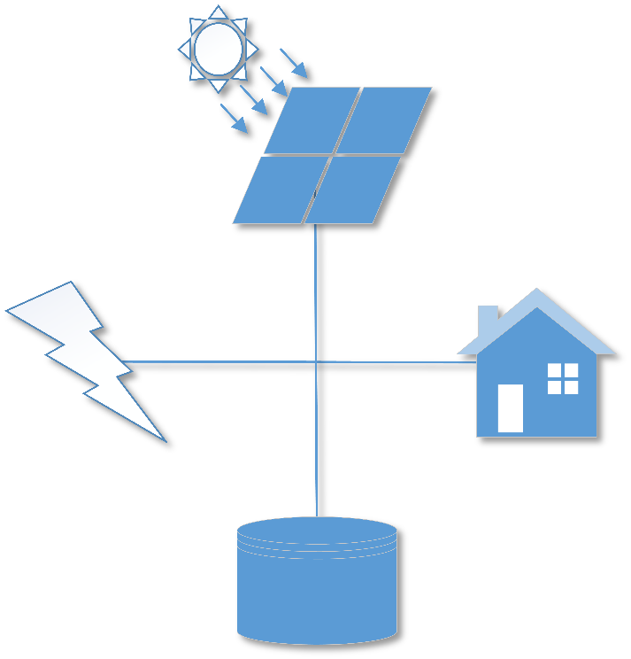

Figure : High-Level Sub-Systems

Figure 1 shows each of the four sub-systems involved: solar (top), the grid (left), the house/load (right), and the battery (bottom). Broken down at this level, each of these sub-systems are related in the following way:

This equation of course assumes values for these systems are in terms of power and there is no energy lost due to any external or internal factors. The relationship between these sub-systems also implies that only three out the four values needs to be known to effectively control the system, as the other can be inferred. Generally, this unknown is either the house/load or the grid as the solar and battery values are often more accessible due to them both being controlled systems put in place by the user. What this means is that by simply measuring the solar intake and house energy consumption (or the grid power), enough data is available for a simple control system to effectively use the battery to negate much of the need for import grid power within the battery’s capacity and efficiency limits. The most clear first approach in this control is effectively make the grid (‘zero the gird’), in other words, battery power is applied at appropriate times with respect to the following equation;

This is called PV self – consumption, and can be represented functionally by the following diagram:

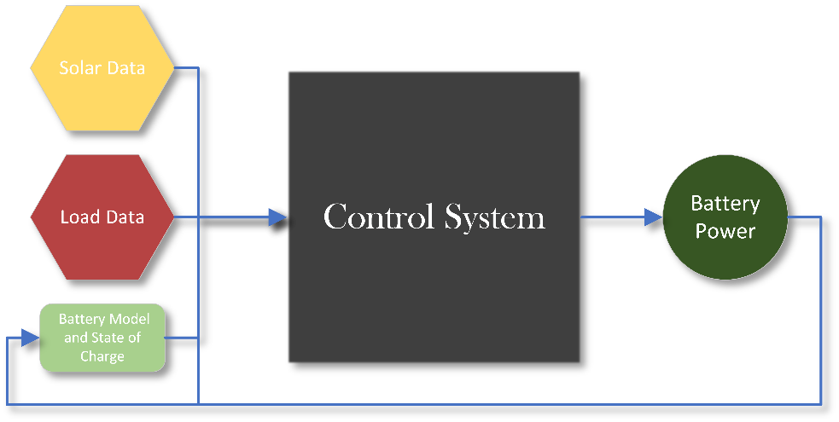

Figure : PV Self-Consumption Closed Loop Control System

One of the major benefits of a system like this is its time independence. The output (being the batteries next power value) is only dependent on the current values of the solar, house, battery power and battery state of charge. What this means is that this system can be implemented as a simple logic circuit and can react as quickly to changes in solar and load data as the designed control system will allow. The results of system like this often result in the battery being charged to full in the early morning sun and discharged to empty as the sun goes down and into the early night. A typical example of this might be as the following figure describes:

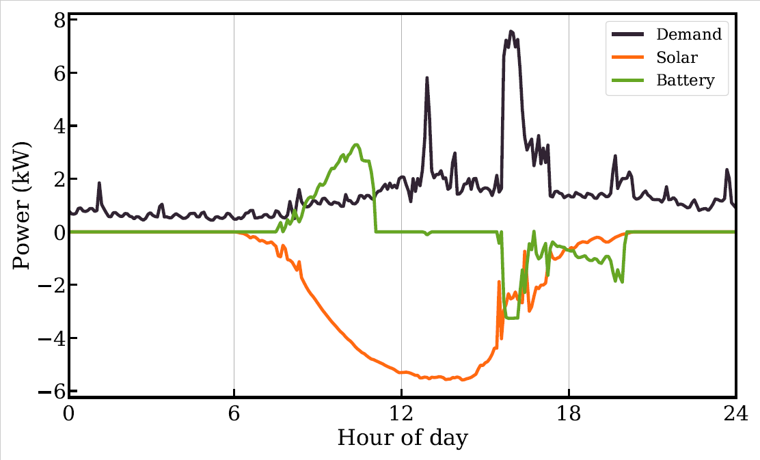

Figure : Typical PV-Self Consumption Battery 24 Hour Response

For reference the battery capacity in the example shown in Figure 3 is approximately 6.2 kWh. However, this response is not always what is desired. In some cases, reducing peak energy import, or import and export during a period or throughout the whole day can save more money and/or be more energy efficient. This type of control is described in most cases by the following equation:

What this also means is that a 24 hour predicition of the house and solar values is needed for this case and therefore can be represented functionally by the following diagram:

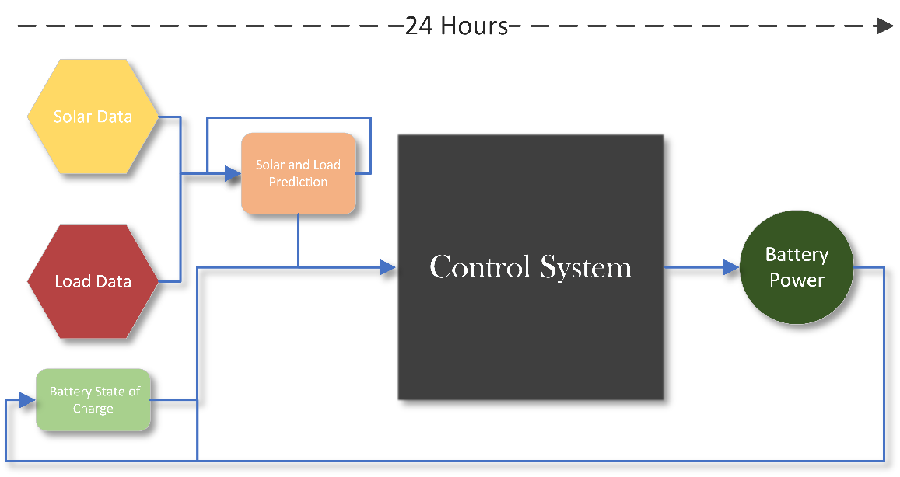

Figure : Peak Minimisation Closed Loop Control System

A typical example of this using the same data and battery capacity of that in Figure 3 might be as the following figure describes:

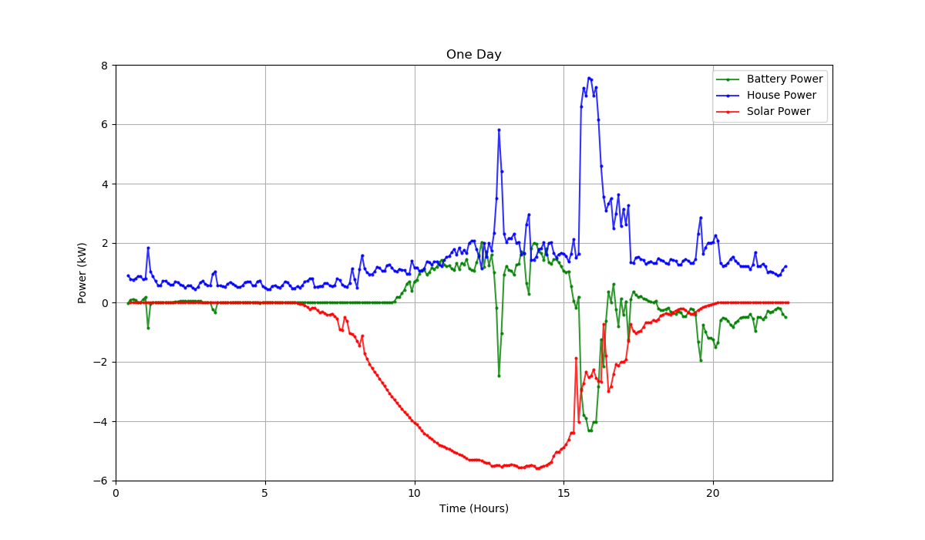

Figure : Typical Peak Minimisation Battery 24 Hour Response

Ignoring the empty data points (this is because Figure 4 was obtained from a real time graph where previous points are removed as the simulation progresses), the figure shows a vastly different battery response in comparison to that of Figure 3. Keep in mind that the response in Figure 4 was generated using a perfect prediction of solar and house data.

Even with these two control methods, neither can guarantee the battery will always have enough charge during the day’s usual peak load times, which may be when the price of import grid power is significantly higher and therefore, the system may be most effective by zeroing the grid during this time specifically. A known method of control that can be used for this is known as load shifting. The terms PV self-consumption and load shifting are often used interchangeably in energy storage literature; however, for this report, load shifting refers specifically to open loop control of the battery using a prediction of the solar curve, though still aims to solve the same equation: . The response of this type of control is generally a smoother curve of what is shown in the battery response of Figure 3, meaning it often does not react to sharp changes in user energy consumption. This is because load-shifting by this definition is not implemented as a real-time control system and relies on a fixed prediction of the solar generation curve and therefore, generates a fixed battery response. Hence a load-shifting only system often acts as an open-loop control model with a 24-hour time-step, and can be represented functionally by the following diagram:

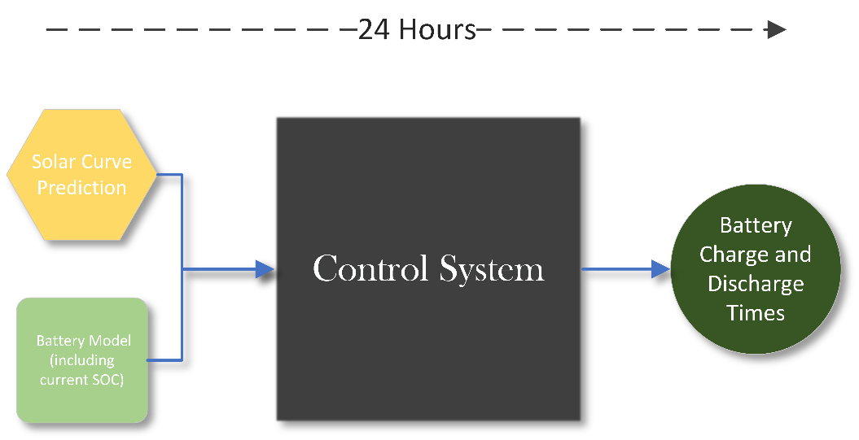

Figure : Load-Shifting Open-Loop Control System

One of the key differences of load shifting and peak minimisation is allowing the battery to charge from the grid, if not enough solar is available. The most obvious reason this may be beneficial, is ensuring the battery gets to maximum capacity during times of cheap grid import prices, so the user can avoid importing grid power during times of high prices as much as the battery will allow.

All of these control systems have different use cases and are more or less effective, depending on the user’s Tariff model (energy provider pricing system), location, budget, battery capacity, and many other factors. It can also be very difficult to know what type of control the battery provider will actually use for the user’s system. The following table describes very generally what each of these control methodologies need to function correctly:

Table : Generalised Comparison of Typical Battery Control Methods

|  |  |  |  |  |
| --- | --- | --- | --- | --- |
|  | Requires Direct Feed of Data (Solar/House/Grid) | Often Used as a ‘Real Time’ System | Needs Updating Future Data Prediction | Can Charge Battery from Grid if Necessary |
| PV Self – Consumption (Closed Loop) | YES | YES | NO | NO |
| Peak Minimisation | YES | YES/NO | YES | YES |
| Load Shifting (Open Loop) | NO | NO | YES | YES |

Table 1 shows of these three simplified control methods, none of them share the same requirements. The one box that states a yes/no is there because the prediction for the solar and house data can and is often also updated in real-time (rather than every 24 hours), though this of course adds extra computational time to each time-step. Along with these requirements it is also important to understand the most valuable use cases for each of these control methods:

* PV Self – Consumption (Closed Loop):
  + Advantageous Use Case: Any instantaneous changes in input data will result in a time-step dependent change in battery power. Such as if a user begins using power during the day and the battery has charge, it will attempt to account for this immediately.
  + Disadvantageous Use Case: If all battery capacity is consumed before high grid import prices begin, it may have been worth not using the battery until this point, but because this system is not dependent on time in any way, this would not occur.
* Peak Minimisation (Closed Loop):
  + Advantageous Use Case: Where pricing is in some way measured by peak energy usage or it makes more financial sense to minimise grid power over any extended period of time.
  + Disadvantageous Use Case: If the prediction does not account for peaks in household energy usage, or it makes most sense to completely zero the grid during a particular period of the day.
* Load Shifting (Open Loop):
  + Advantageous Use Case: Making sure the battery is correctly charged for when grid import prices arrive (almost always in the evening). Under many systems, this control method may behave almost the same as PV self-consumption and could be easier to implement.
  + Disadvantageous Use Case: Using a bad prediction, such as using a very sunny solar curve on a very rainy day, making the battery charge almost entirely off of the grid. Or just discharging at times when the battery is not needed.

So, the important question becomes: ‘How do we know which control option makes most sense at any given time on any given day?’ and the answer is unfortunately we don’t, just like using any one of these control methods by themselves will result in scenarios where they perform unfavourably. But, we can however, make a very good estimate. The reason we can make this estimate at all is for a number of reasons relating to optimisation criteria, but the two major reasons are:

1. The data for each day in PV solar systems is often very similar and follows similar curves and trends, even with household energy consumption and therefore, prediction methods for future data do not need to be overly complicated, greatly reducing computational overhead and increasing prediction accuracy.
2. All of these control methods share similar input data types, and more importantly, almost the same objective: to save energy for the system and money for the user.

This is why a higher-level control system can be used, where these control methods are now objective functions to be compared in optimisation. Also, including the import and export Tariff information provides the addition for purely financial based objectives. This control system can now be represented functionally by the following diagram:

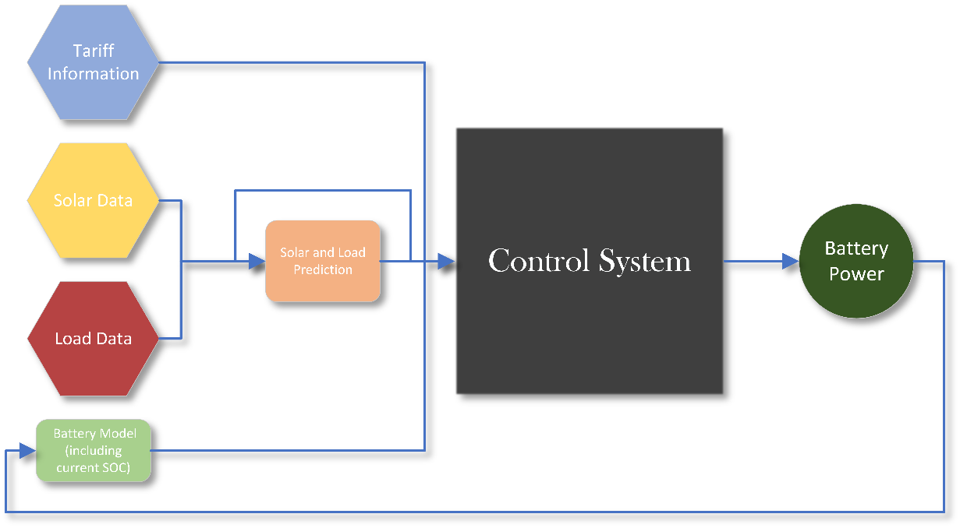

Figure : Optimisation Battery Control System

## Input Data Systems

For the control system to use the various data types it needs; solar, house/load, battery, etc. it needs systems in place to obtain and store this information. Different PV models will use different protocols to do this, though one commonly used, and well understood method is communication via servers. Using this method allows data to be arranged and categorised via server addresses, meaning accessing the correct data can be as simple as knowing which address it is stored in. Solar systems may choose to create a separate server for load information, making a total of three servers including one for the battery. These server systems may come in many forms such as ‘TCP’, ‘UDP’, Modbus, etc. though the principle of obtaining the data remains the same. However, there is often another sub-system that directly handles the data from the servers before it can be used by the control system. This sub-system is often known as the drivers, and are hence situated in this system in the following way:

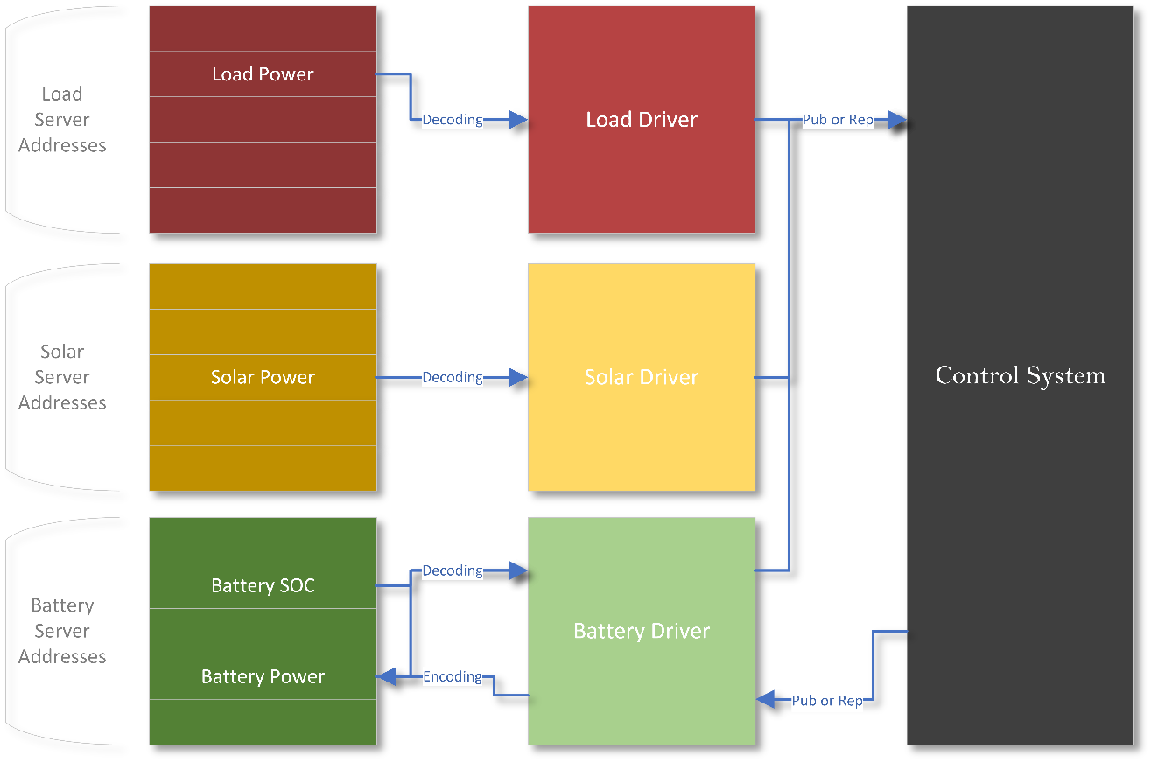

Figure : Input Data Systems Overview

There are two main reasons these drivers in most cases need to exist:

1. One system may involve a variety of server protocols with its various devices and the drivers ensure that even with information coming in different forms, the control system does not need to care and should always receive information in the same format.
2. The drivers control the flow of information, this helps greatly in synchronising data, and simplifying data handling for the control system.

Many systems will use different ways of controlling the data flow, though usually involve one of the two major asynchronous and synchronous data protocols. Those being the ‘publish/subscribe model’ (pub-sub) and the ‘request/reply model’ (req-rep). The pub-sub model means that the control system will subscribe to the driver and only receive data when the driver publishes, so the data flow is handled mostly on the driver side. The req-rep model means that the control system will only receive new data when it requests it from the driver, so the data flow is handled mostly by the control system. The following figure shows visually how each of these models work:

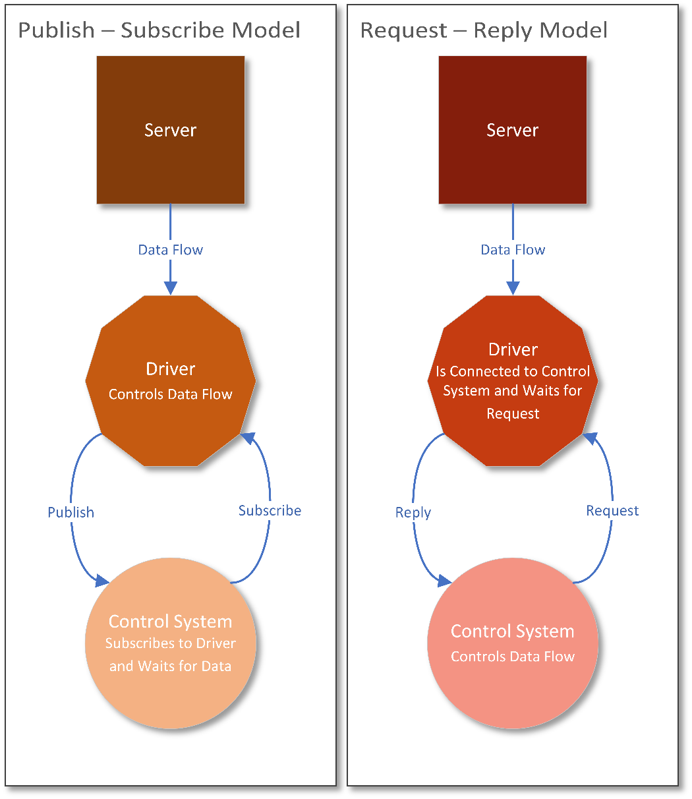

Figure : Logical Breakdown of Pub-Sub and Req-Rep Models

The servers and drivers will hence ensure that communication is structured, effective and controlled, but generally do nothing to ensure the data’s validity. Therefore, filtering becomes necessary, as without it, one outlying value could significantly decrease the accuracy of the entire control system for an extended period. Data filtering can be performed at many steps in the input data’s logical flow, though is most commonly performed either by the drivers or within the control system. For the purposes of higher-level control systems, it often makes more sense to filter the data within the control portion, as filtering may be something that needs altering or even dynamic control, and the drivers typically are a static program. There are numerous filters that exist for one-dimensional data filtering including [???], though a well-established example for this type of data would be the Kalman filter. This filter works by establishing a prediction model of new data with an associated probability (prior), and updating this prediction model based on new measurements with an associated covariance and new probability (posterior), the one-dimensional Kalman filter is the simplest version of this, and can be used to ‘smooth’ data, or update any data model based on new information. For the optimisation-based control system, this filter can be used in two cases: To ’smooth’ out data arriving from the solar and house/load, as well as update the future prediction needed for optimisation based on new data. A basic example of this one-dimensional Kalman filter implemented in a Python environment is outlined in the figure below:

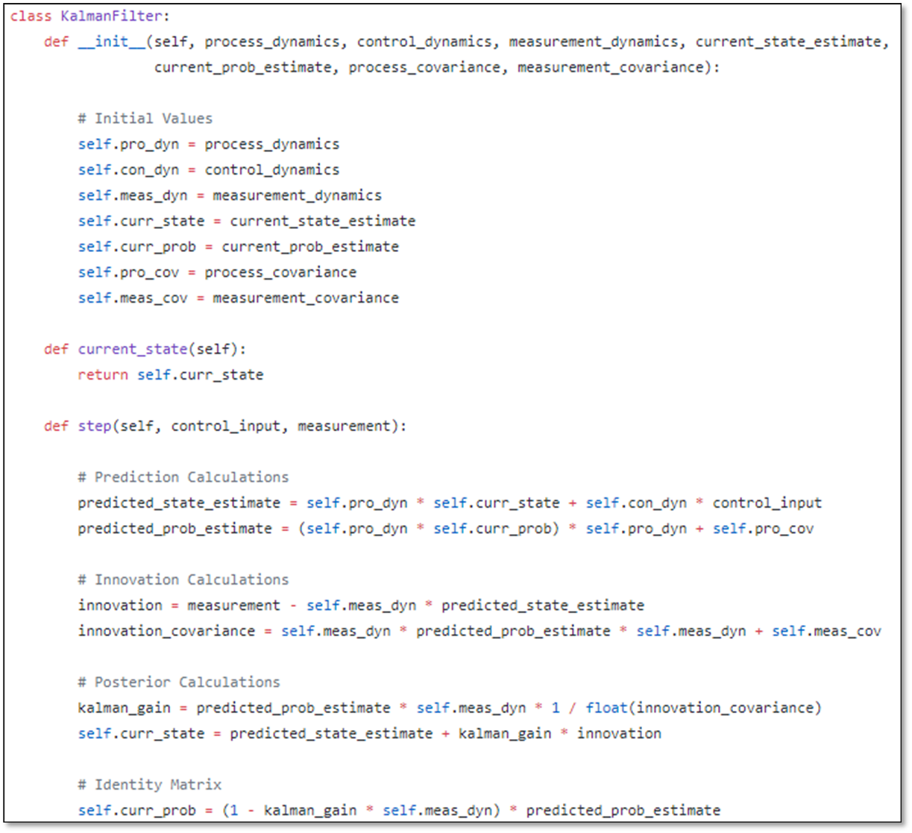

Figure : One-Dimensional Kalman Filter Python Code Example

As the code example shows this, filter has a ‘prediction’ step, an ‘update’ step and a ‘Kalman gain’ step which only executes if a new measurement is received and is used to update the current prediction.

With these systems in place, controlled and filtered data can be used by the control system, and in turn produce the battery power values required, which are written to the battery’s server.

## Battery Models

The batteries themselves are complicated devices, involving a large quantity of parameters that can define its characteristics. These involve its various limits, efficiencies, estimated lifespans, and other quantities that define how the battery behaves. Some typical values of current market energy storage solutions available in Australia are shown below:

Table : Typical Specifications for Popular Energy Storage Solutions

|  |  |  |  |
| --- | --- | --- | --- |
|  | Tesla – Powerwall 2 | SolaX - Triple Power | LG RESU High Voltage |
| Power (Continuous) | 5kWh (7kWh peak) | Up to 10kW | Up to 5kW |
| Capacity | 13.5kWh (AC) | 5.8kWh, 11.6kWh, 17.4kWh, 23.2kWh | 9.3kWh |
| Depth of Discharge | 100% | 90% | 90% |

(SolarHub, 2019)

For some reference, a typical solar home in Sydney using a 5kW system of optimally tilted PV panels can produce around 15 kWh of power during a winter’s day and around 26 kWh of power on a summer’s day (Solar Choice, 2019); and typical household energy consumptions for this area and surrounding regions are approximately 15kWh per day (Ausgrid, 2018).

It is important for these systems to then have a prediction of how the battery will respond to its inputs. For the real control system this can be used to measure the battery’s health and effectiveness. But for simulated systems, this can be used to test how the battery will perform, leading to testing on the entirety of the control system. To do this a model of the battery is essential and doesn’t need to be overly complicated as if you are assuming the model represents ideal conditions, then many simpler models will produce the same results as there more realistic counterparts. For example, a standard explicit-Euler model of the battery will work for many simulation related purposes. It follows the following equation:

Using this model, the simulation can hence determine how the state of charge will change in response to power inputs.

## Motivations

Even with energy storage’s impressive set of control capabilities, the investment is still not worth it for a vast majority of Australians. This is mainly because of the current technology’s limitations and the capital cost that consumers must pay to invest. These two concepts create an inherent compromise between the battery’s ROI, and its estimated effective lifespan. Reports from ??? show that currently the addition of some energy storage solutions can almost double a residential PV system’s ROI period, bringing into question the length of battery warranties and the expected level of performance when that runs out. As buying another battery after this period due to degradation is anything but what the customer wants. However, it is not all bad news for the technology. Increased interest from various governments, residents with existing PV solutions and a general push towards renewable energies have rapidly pushed the industry forward. Not only improving the efficiency of the products but reducing their cost on the commercial market. Implicating that as time goes on, the number of people who live under energy storage fit circumstances will drastically increase. South Australia Blah Blah. However, there is still a general lack of consumer knowledge on how the control aspect of these systems work and how different methodologies may benefit them. Server based systems provide an accessible way of testing these concepts with real data using exact protocols. Therefore, building a simulated system under these hardware based protocols, within a well – established developmental programming environment not only enables this testing, but creates opportunities for others to improve upon the systems and learn from its outcomes going into the future where, these systems will inevitably become the attractive residential solution they are intended to be.

## Thesis Outline

The specific objective of this project is to create this simulated battery control system based on hardware protocols within a Python environment. Python was chosen for three main reasons:

1. It is a very well-established high-level programming language, meaning there would be a breadth of knowledge on similar solutions.
2. Python is often used as an open-source development language and therefore, an enormous amount of these libraries exist that can simplify the development process and make future improvements easier.
3. The Python language is deeply embedded in many Linux based distributions and therefore, opens the software to other potential applications in the future involving Linux based solutions.

This Python based software will be used to test variations of input data, to study how the control responds over time and explore how the structure of this system creates many capabilities and limitations that have implications for its user.

The following sections will explore first the related research currently existing that explore the viability and limitations of these high-level battery control systems under a variety of circumstances. Followed by a section showing the design methodologies and specific solutions used in the software, their capabilities and limitations, the testing methods needed to effectively obtain outcomes from simulations, and finally the results from the simulations. Finally two sections discussing the results obtained from these simulations, and the conclusions that we can draw from them.

# Background and Related Work

Blah

## Existing Battery Systems

Blah

## Current Viability Research

The idea of idly saving money from a financial investment has always been an attractive selling point for products on the consumer market. With almost 10,000 PV solar panels being installed per day in Australia during 2017 (Lipson, 2018), solar energy not only provides an accessible way for residential Australians to reduce their household carbon footprint, but also sells because of it promise to save money past its initial return on investment period. However, one of the renewable energy’s biggest drawbacks is of course its dependency on the weather; a problem that’s current most straightforward solution is the addition of battery storage alongside solar energy. The Australian National Universities (ANU) Battery Storage and Grid Integration Program (BSGIP) is currently working to optimise, control and expand this solution beyond simple PV-self consumption (charging and discharging the battery only from the solar panels, when it makes sense to do so).

Prior to the work of the BSGIP, research was done in different countries under different electricity schemes into the viability of these battery systems using some more advanced versions of control. Specifically, there was an interest into the economic effectiveness of load-shifting: Charging the battery during times of cheap grid power and selling back to the grid (discharging) during times where the price for selling back is at its highest (dynamic tariff); as well as some hybrid of this and PV self-consumption depending on what made more financial sense at any time. Pena-Bello et al provide a thorough review of the variety of this research completed up to 2017, as well as their own investigation into the viability of such systems in Switzerland (Pena-Bello et al., 2017). They, along with much of the research cited, concluded that if PV solar panels were already installed then adding battery storage was not worth its initial capital cost. Though if battery storage was already in use then as long as the capacity exceeded 4kWh, dynamic battery control using both PV self-consumption and load-shifting proved to make a positive difference financially. Though it was mentioned that under different grid and battery pricing conditions PV and battery control systems could become much more attractive. Other research indicated that battery control systems can lead to a significant reduction in cost associated with energy consumed from the grid such as the work done by Alramlawi et al, though this was done mainly with respect to grid scheduled blackouts (Alramlawi et al., 2018), as well as the research completed by Munzke et al., 2018: Which suggests that having an intelligent control method in a PV-battery storage system does provide slight economic benefits over a generic system of the same type, especially in helping to reduce battery ageing (Munzke et al., 2018). It is also mentioned that in the future when these battery technologies become more financially viable and of higher capacities and lifespans, then advanced control strategies will make a more significant difference in long-term energy cost savings.

Australia, however, often has far more consistent sunny weather conditions than many of the countries these investigations took place in. Research conducted here indicates that the purchasing of battery storage is currently significantly up from recent years (Lovell and Watson, 2019), and can create much higher levels of savings with the correct amount of PV and storage used (Li, 2019). This is part of the reason why the BSGIP has taken an interest in not only supporting this movement for obvious environmental reasons, but because these systems can be further optimised and controlled for various objectives, including economic benefits and creating shared electricity resources. Although much of the control and financial optimisation techniques have already been investigated by the team, there is some lack of software for use in an open-source development setting. The software developed for this project will hence enable the team to test the viability, both in a financial and pure control sense, of residential PV solar and battery systems in isolation and part of a larger network.

## BSGIP’s Work

Blah

# A Python Based Battery Control System

Blah

## Hardware Simulation and Program Abstraction

Blah

## System Capabilities and Limitations

Blah

## Testing Methods

Blah

## Results

Blah

# Discussion

Blah

## Technical Assumptions

Blah

## Results Implications

Blah

## Financial Incentives

Blah

# Conclusions

Blah

## Battery Systems’ Current Viability

Blah

## An Open-Source Solution

Blah

# Bibliography

Alramlawi, M., Gabash, A., Mohagheghi, E., Li, P., 2018. Optimal operation of hybrid PV-battery system considering grid scheduled blackouts and battery lifetime. Solar Energy 161, 125–137. https://doi.org/10.1016/j.solener.2017.12.022

Ausgrid, 2018. Average electricity use - Ausgrid [WWW Document]. URL https://www.ausgrid.com.au:443/Industry/Innovation-and-research/Data-to-share/Average-electricity-use (accessed 9.28.19).

Li, J., 2019. Optimal sizing of grid-connected photovoltaic battery systems for residential houses in Australia. Renewable Energy 136, 1245–1254. https://doi.org/10.1016/j.renene.2018.09.099

Lipson, D., 2018. Our love of solar power could soon become a serious problem [WWW Document]. ABC News. URL https://www.abc.net.au/news/2018-03-07/solar-power-what-happens-when-theres-too-much/9522192 (accessed 5.28.19).

Lovell, H., Watson, P., 2019. Scarce data: off‐grid households in Australia. Energy Policy 129, 502–510. https://doi.org/10.1016/j.enpol.2019.02.014

Munzke, N., Schwarz, B., Hiller, M., 2018. Intelligent control of household Li-ion battery storage systems. Energy Procedia, 12th International Renewable Energy Storage Conference, IRES 2018, 13-15 March 2018, Düsseldorf, Germany 155, 17–31. https://doi.org/10.1016/j.egypro.2018.11.069

Pena-Bello, A., Burer, M., Patel, M.K., Parra, D., 2017. Optimizing PV and grid charging in combined applications to improve the profitability of residential batteries. Journal of Energy Storage 13, 58–72. https://doi.org/10.1016/j.est.2017.06.002

Solar Choice, 2019. 5kW solar systems: Pricing, output, and returns [WWW Document]. Solar Choice. URL http://www.solarchoice.net.au/blog/5kw-solar-system-price-output-return/ (accessed 9.28.19).

SolarHub, 2019. Solar Battery Storage | Energy Storage. SolarHub. URL https://www.solarhub.net.au/energy-storage/ (accessed 9.28.19).